1. Sales by Customer <https://us3.ca.analytics.ibm.com/bi/?perspective=explore&pathRef=.my_folders%2Fsales_by_customer&subView=model000001837da68480_00000003>

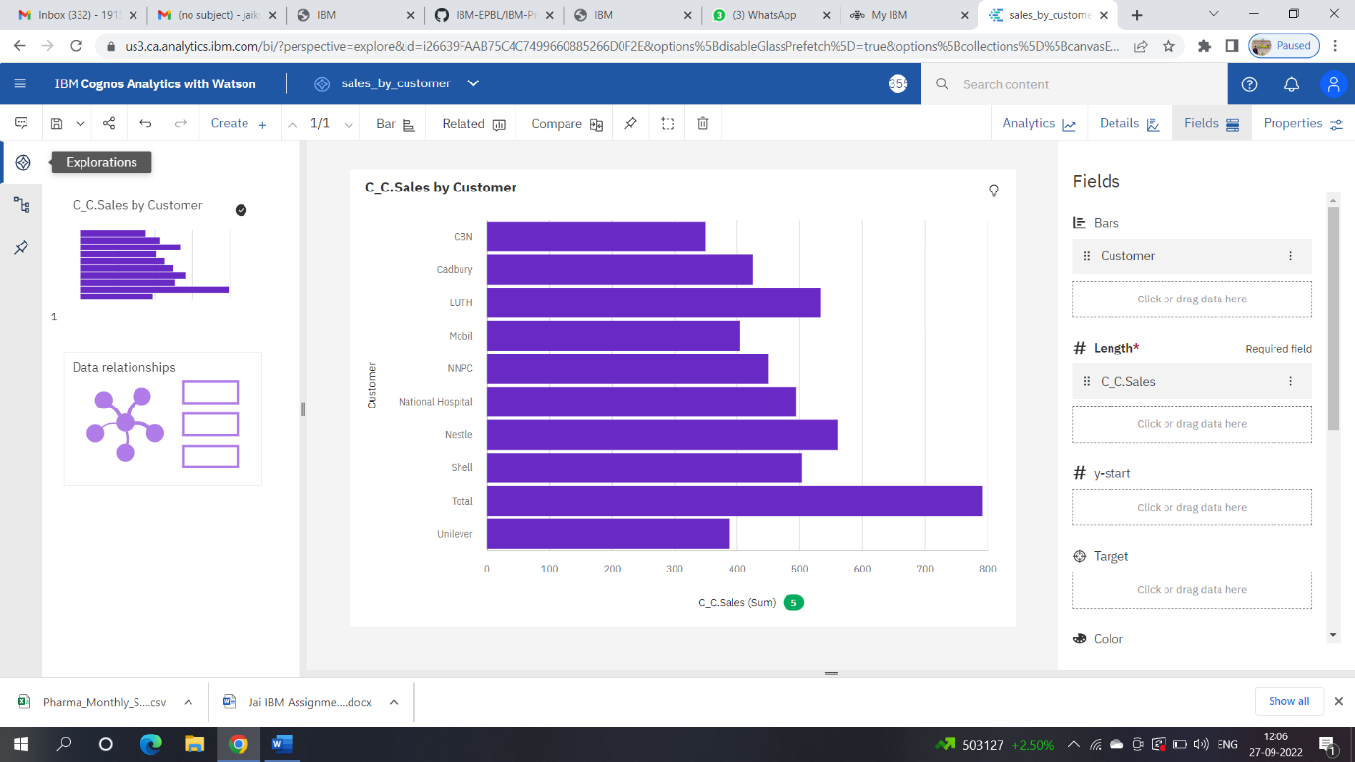

1. Sales by Location <https://us3.ca.analytics.ibm.com/bi/?perspective=explore&pathRef=.my_folders%2Fsales_by_location&subView=model000001837da977db_00000000>

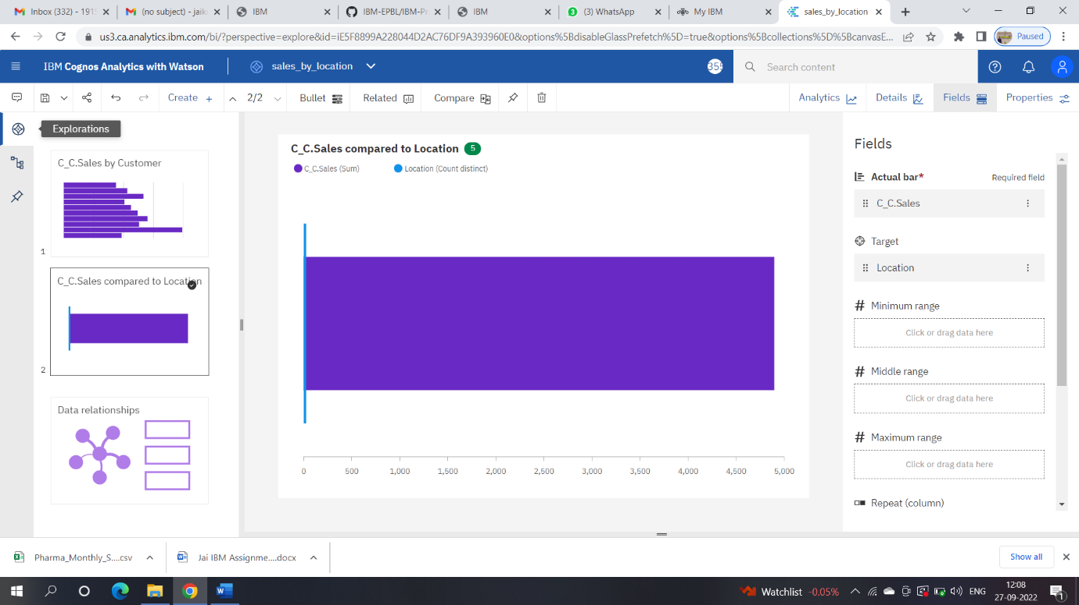

1. Sales by Sales Representative <https://us3.ca.analytics.ibm.com/bi/?perspective=explore&pathRef=.my_folders%2Fsales_by_rep.sales&subView=model000001837dac7378_00000003>

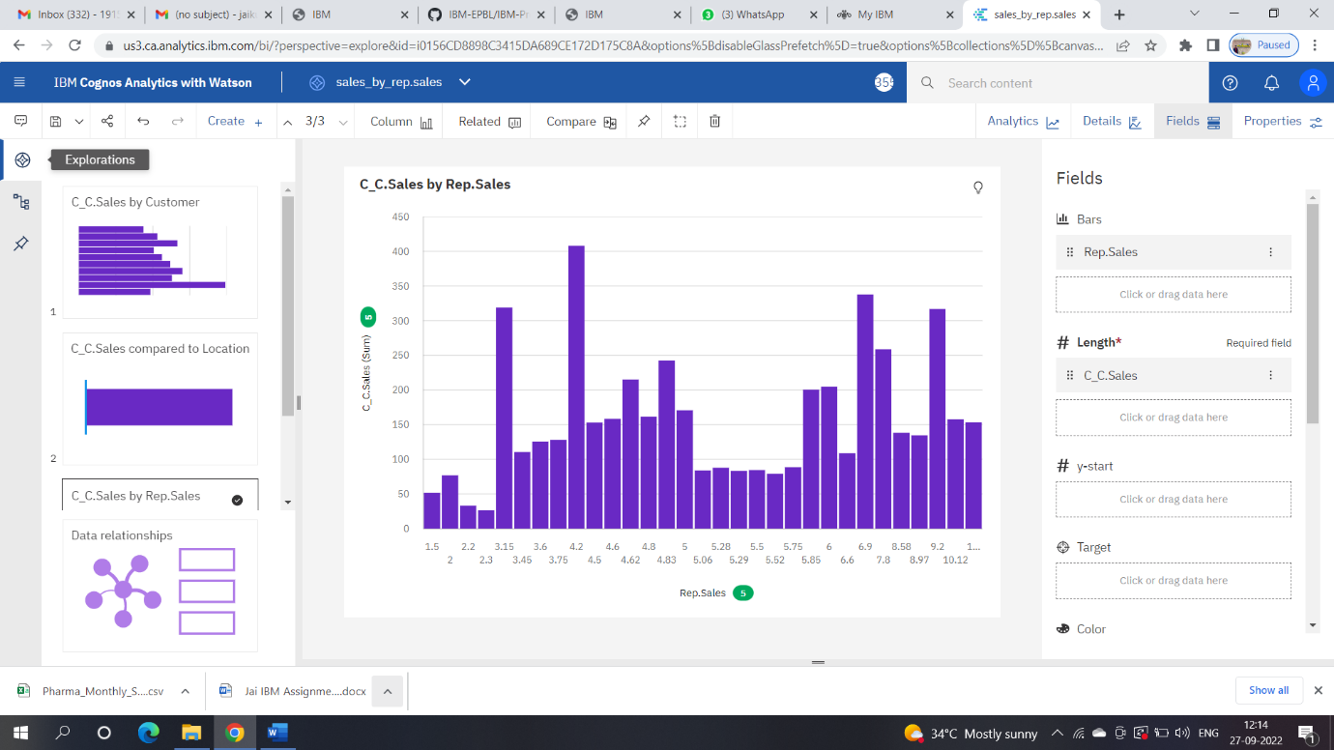

1. Received inventory from supplier <https://us3.ca.analytics.ibm.com/bi/?perspective=explore&pathRef=.my_folders%2Freceived%2Binventoery%2Bfrom%2Bsupplier&subView=model000001837db1aeb3_00000000>

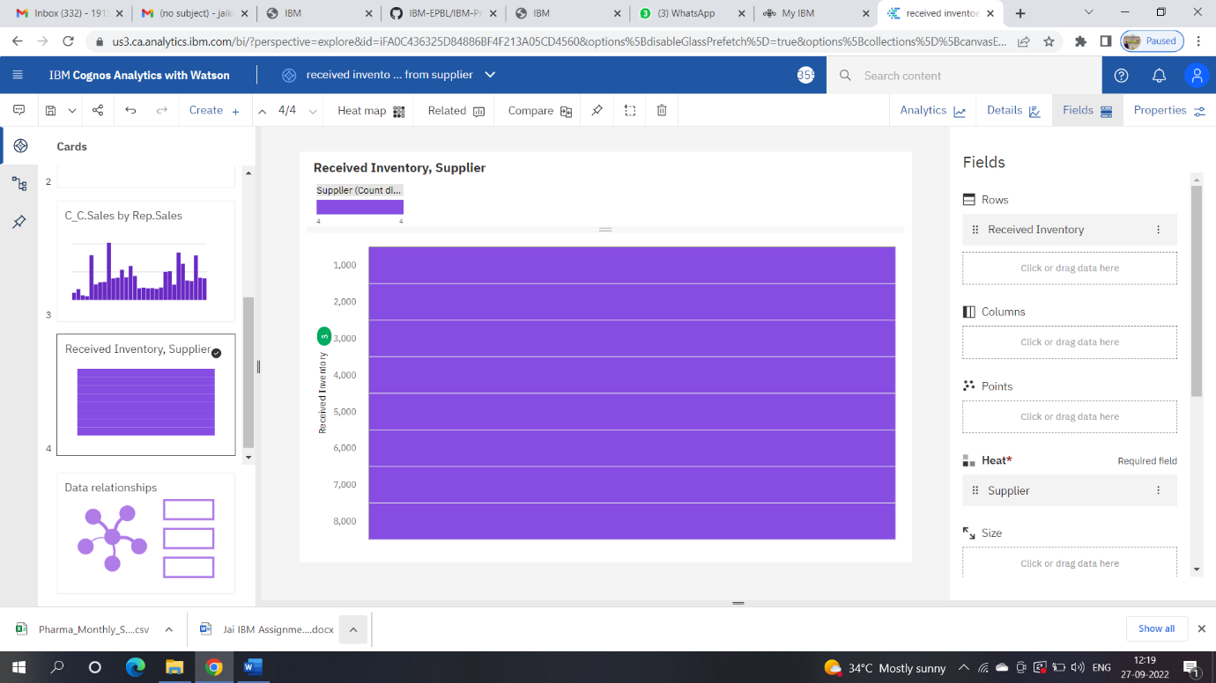

1. Inventory stock for Warehouse locations <https://us3.ca.analytics.ibm.com/bi/?perspective=explore&pathRef=.my_folders%2Finventery%2Bwarehouse&subView=model000001837db55384_00000004>

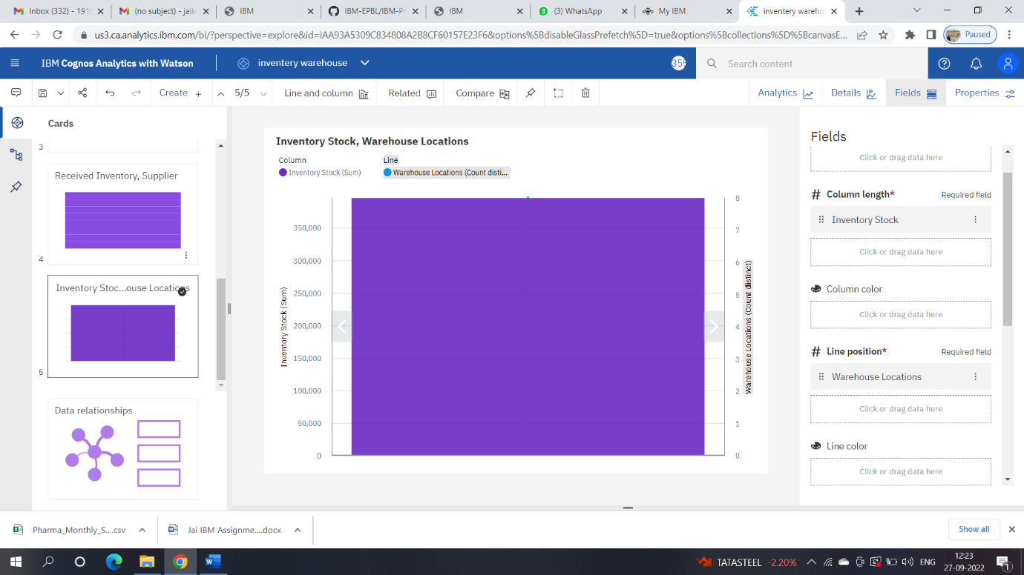

1. Sales Trend <https://us3.ca.analytics.ibm.com/bi/?perspective=explore&pathRef=.my_folders%2Fsales%2Btrend&subView=model000001837db90f49_00000000>

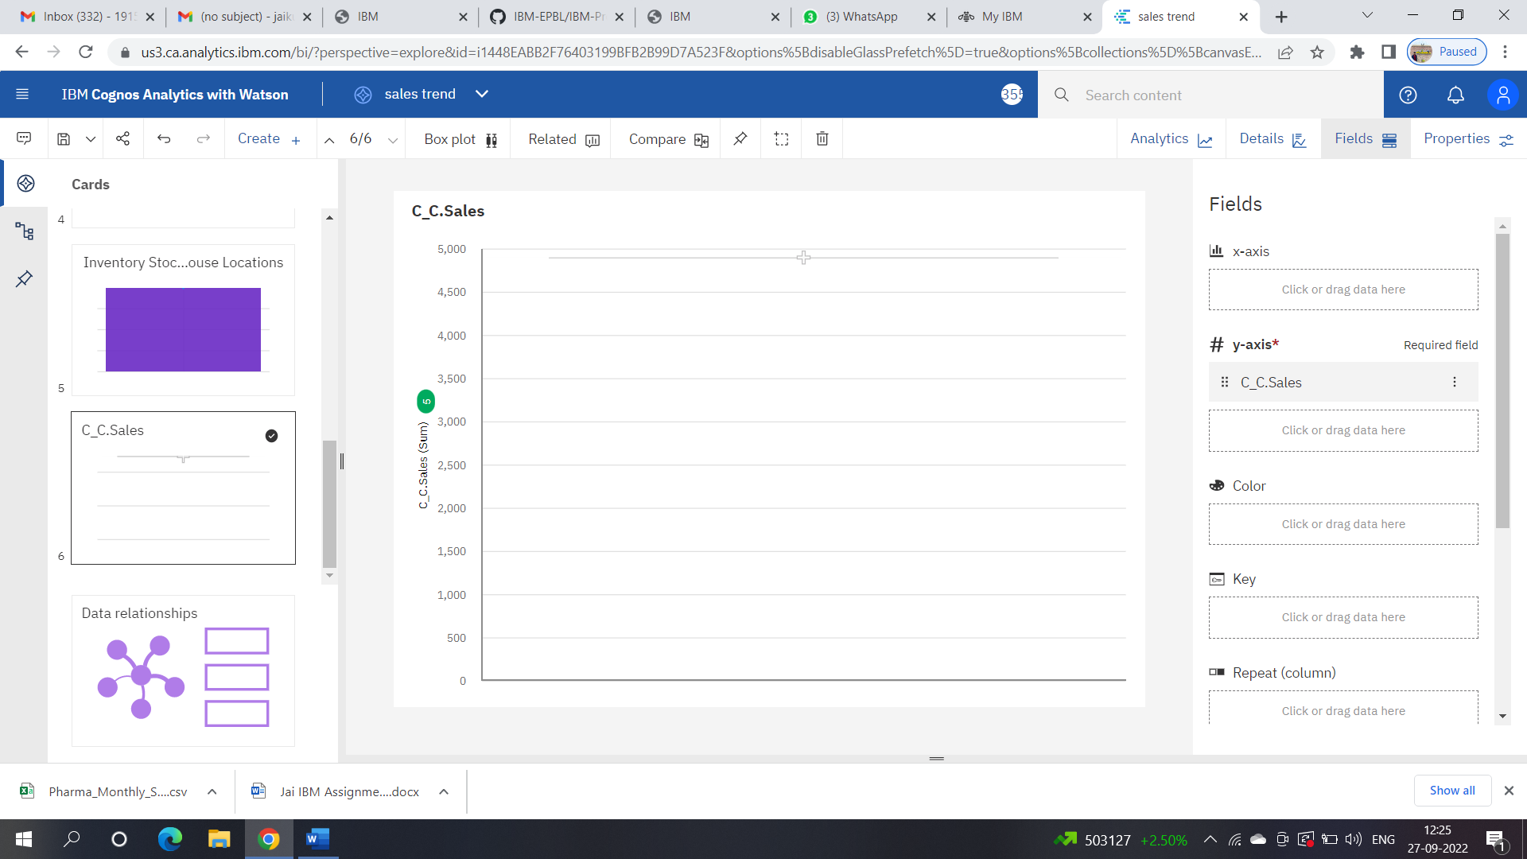

1. Monthly Sales <https://us3.ca.analytics.ibm.com/bi/?perspective=explore&pathRef=.my_folders%2Fmonthly%2Bsales&subView=model000001837dbb5822_00000002>

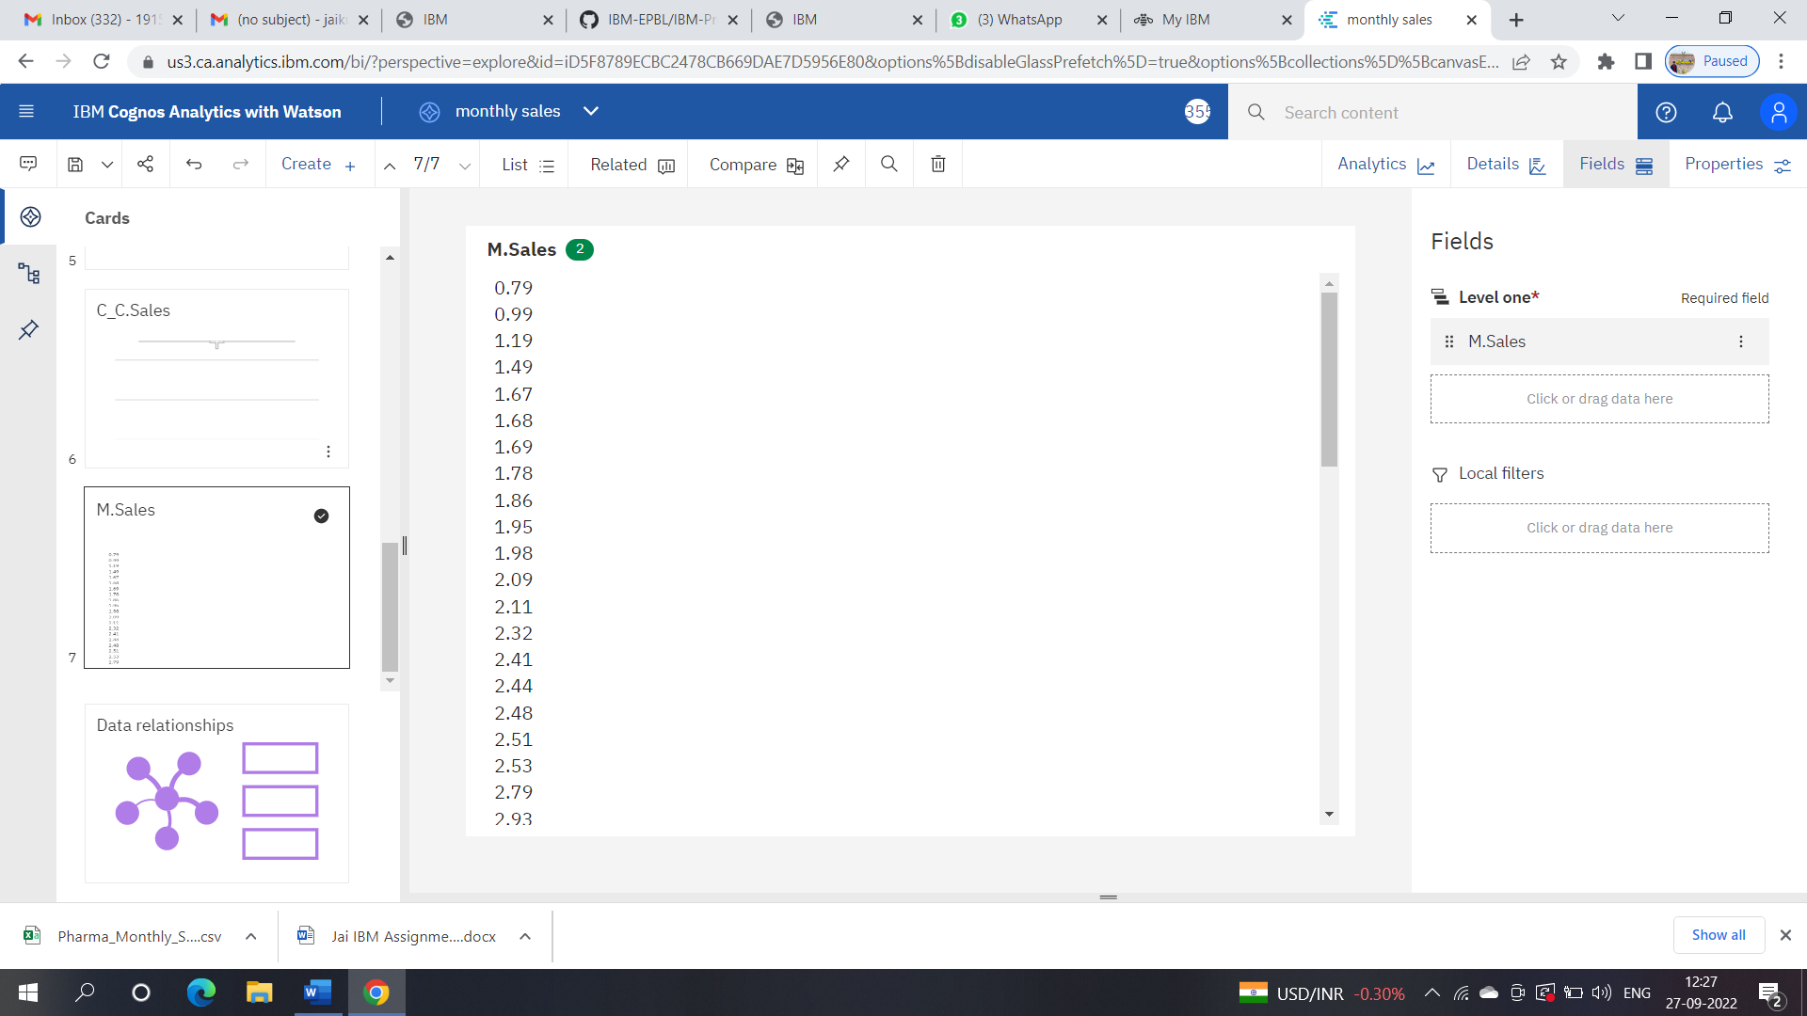

1. Actual and received inventory by month <https://us3.ca.analytics.ibm.com/bi/?perspective=explore&pathRef=.my_folders%2Factual%2Band%2Breceived%2Binventory%2Bby%2Bmonth&subView=model000001837dbcc3a9_00000000>

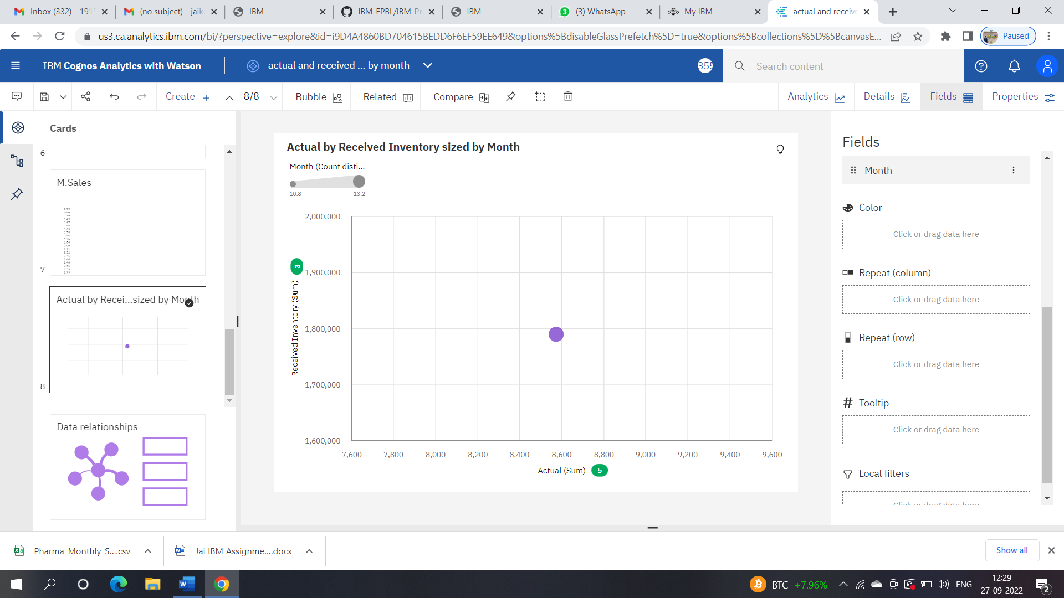

Dashboard

<https://us3.ca.analytics.ibm.com/bi/?perspective=dashboard&pathRef=.my_folders%2FNew%2Bdashboard&action=view&mode=dashboard&subView=model000001837dc26066_00000003>

